Create two component parent and child.

Condition 1: Pass method as a prop from parent to child

Condition 2: First Satisfy condition and try to pass parameter from child to parent.

**Condition 1:** Pass method as a prop from parent to child

import React, { Component } from 'react'

import ChildComponent from './ChildComponent'

class ParentComponent extends Component {

    constructor(props) {

      super(props)

      this.state = {

           parentName: 'Parent'

      }

      //1.1 binding here

      this.greetParent=this.greetParent.bind(this)

    }

    //Step : 1 In Parent define the method

    greetParent(){

        //alert('Hello '+ this.state.parentName)

        //1.1 we are using this so we have to bind this in cobstructor

        alert(`Helloo ${this.state.parentName}`)

    }

  render() {

    return (

      <div>

        {/*Step 2: Pass the method as a prop */}

        <ChildComponent greetHandler={this.greetParent}></ChildComponent>

      </div>

    )

  }

}

export default ParentComponent

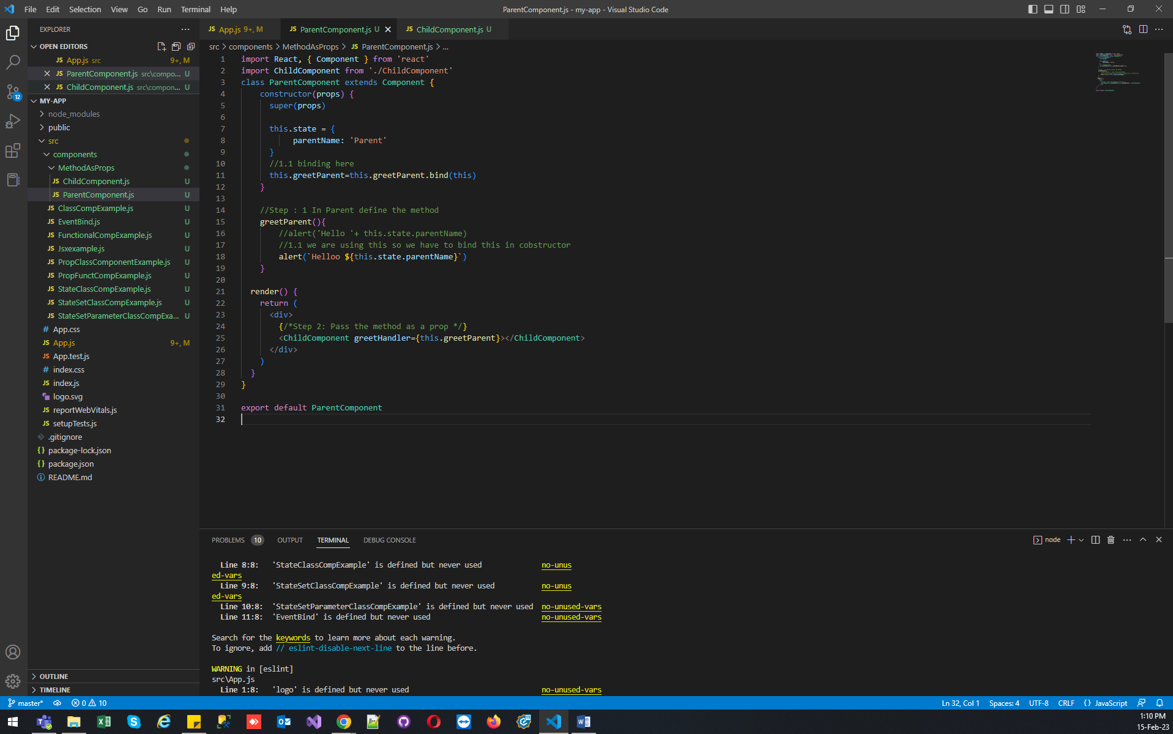

In Child Component :

import React from 'react'

function ChildComponent (props){

  return (

    <div>

       {/*Step 3: In the child component acces the method as a prop */}

      <button onClick={props.greetHandler}>Greet Parent</button>

    </div>

  )

}

export default ChildComponent

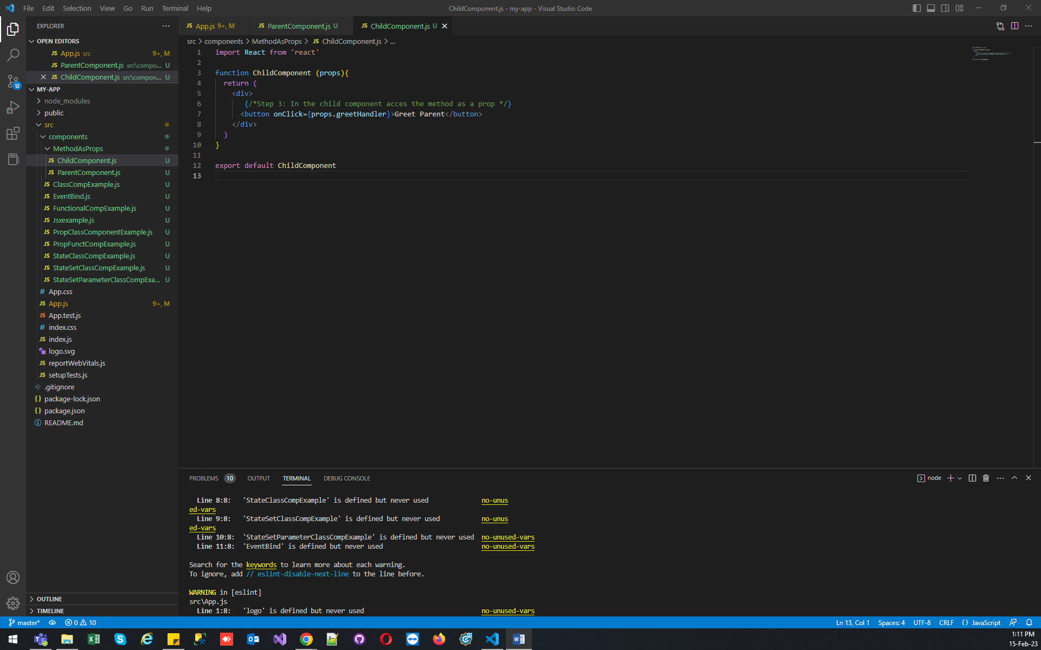

**Condition 2:** First Satisfy condition and try to pass parameter from child to parent.

In child use arrow functions to call method with param

{/*Step 3: In the child component acces the method as a prop and also want to pass parameter create arrow function */}

      <button onClick={()=> props.greetHandler('child')}>Greet Parent</button>

Code :

import React from 'react'

function ChildComponent (props){

  return (

    <div>

       {/*Step 3: In the child component acces the method as a prop */}

      {/* <button onClick={props.greetHandler}>Greet Parent</button> */}

       {/*Step 3: In the child component acces the method as a prop and also want to pass parameter create arrow function */}

      <button onClick={()=> props.greetHandler('child')}>Greet Parent</button>

    </div>

  )

}

export default ChildComponent

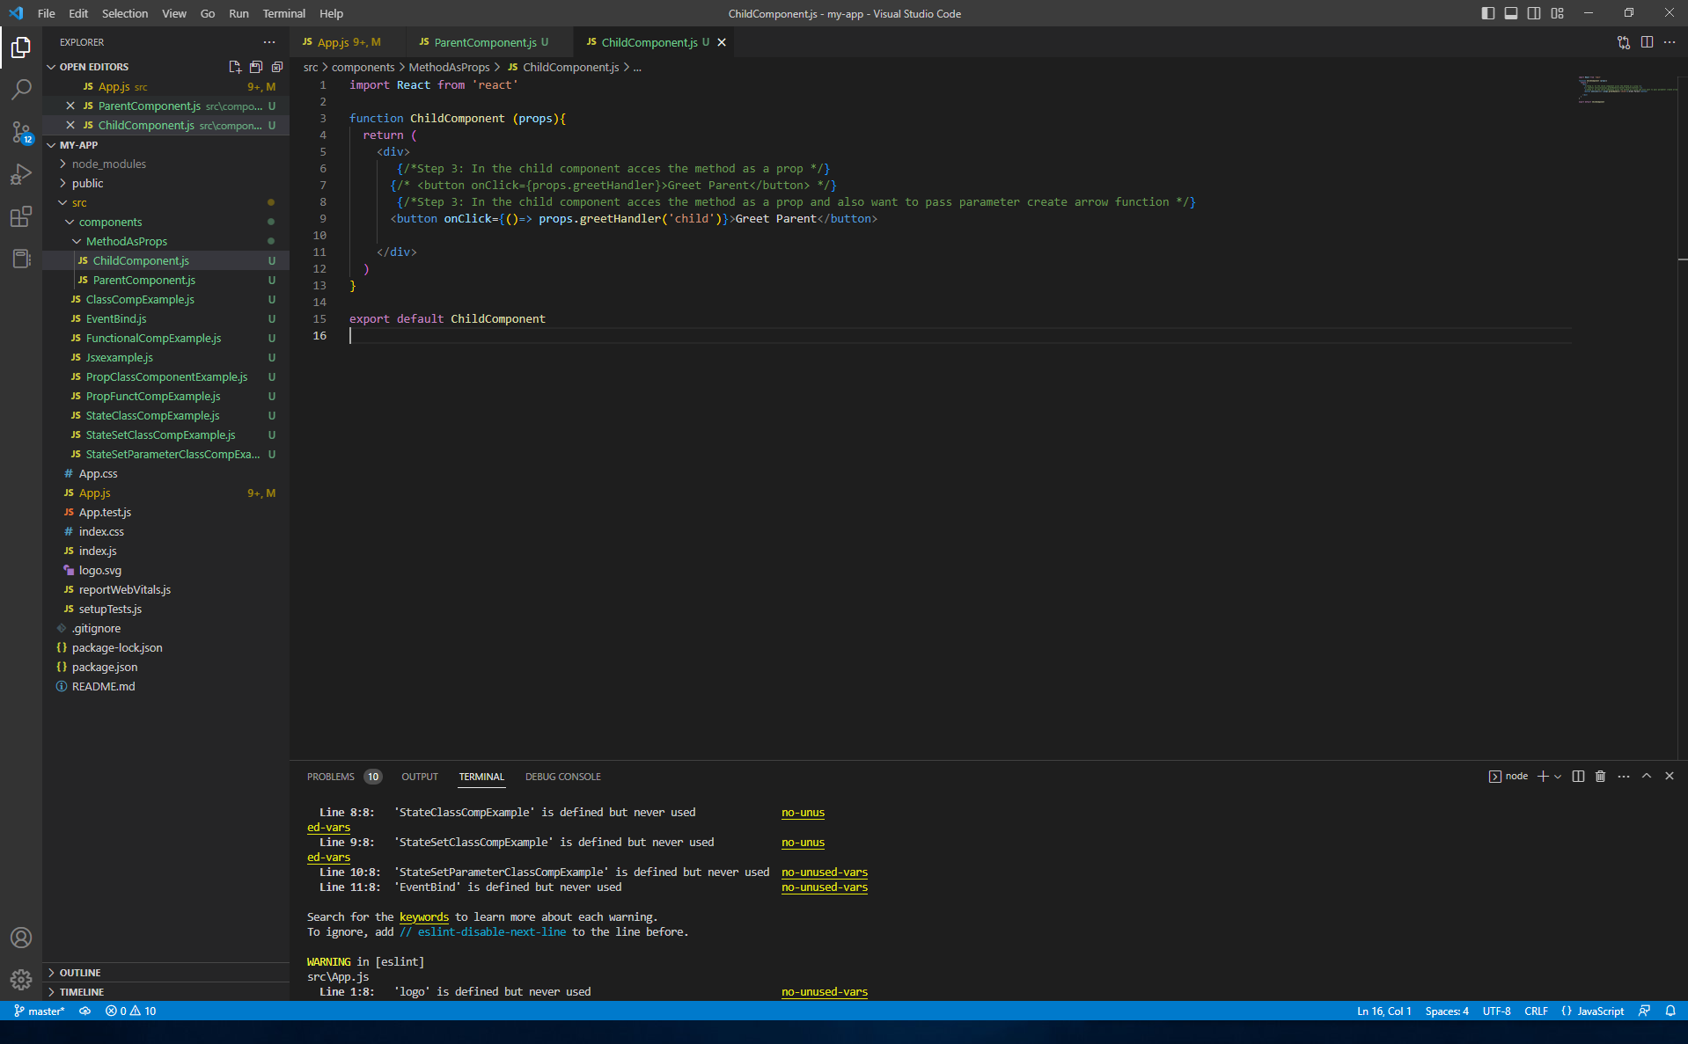

In Parent Component add parameter to the method :

  greetParent(childName){

        //alert('Hello '+ this.state.parentName)

        //1.1 we are using this so we have to bind this in cobstructor

        alert(`Helloo ${this.state.parentName} from ${childName}`)

    }

